**ORPHACONNECT: AN INTEGRATED SYSTEM FOR CHARITABLE INITIATIVES TO ENGAGE COMMUNITIES**

**Jenson Y 1, Raja Selvam M2, S. Shalini3**

*12UG Scholar, Department of Computer Science and Engineering*

*3Head Of the Department (HOD), Department of Computer Science and Engineering*

*123Prince Dr. K. Vasudevan College of Engineering and Technology, Chennai, Tamil Nadu, India*

-----------------------------------------------------------****----------------------------------------------------------

**Abstract -** *Food wastage presents a global challenge with significant societal, economic, and environmental implications. To address this issue and support vulnerable communities, we propose the development of a holistic charity web application. This platform facilitates various forms of donations to orphanages, including food and fund charity, while incorporating features to ensure authenticity, security, and user engagement. Donors can post surplus food availability details, triggering real-time notifications to nearby orphanages. The app guides the donation process, ensuring transparency and legitimacy through authentication OTP. Donor engagement is incentivized through a level-based reward system, encouraging sustained contributions. Additionally, a robust security algorithm prevents fraudulent activities, while user feedback drives continuous improvements. By leveraging technology to streamline the donation process and promote accountability, our project aims to make a meaningful impact in reducing food wastage and supporting orphanages worldwide.*

**Keywords: Seamless donations, Real-time notifications, Level-based reward system, Authenticity, Fraud prevention, User feedback, Enhanced UX.**

Fig 1.1 Food Wastage statistics

1. **INTRODUCTION**

Charitable giving stands as a timeless testament to the universal values of empathy, solidarity, and compassion that bind humanity together. It transcends boundaries of geography, culture, and socioeconomic status, serving as a beacon of hope in a world marred by inequalities and injustices. From addressing immediate needs like hunger and shelter to fostering long-term solutions such as education and healthcare access, acts of charity represent a fundamental pillar of social welfare and progress.

At the crux of charitable endeavors lies the imperative to optimize resources and maximize impact. Among the myriad challenges facing humanity, food wastage emerges as a glaring concern, with a staggering 931 million tonnes of food squandered annually worldwide. This not only signifies a profound missed opportunity to alleviate hunger and food insecurity but also exerts a detrimental toll on the environment and economic efficiency.

In response to this multifaceted dilemma, our research embarks on a journey that extends beyond the narrow confines of food charity to encompass a broader exploration of philanthropy in its myriad forms. By delving into the root causes, far-reaching consequences, and potential solutions to food wastage and other societal challenges, we endeavor to craft comprehensive strategies for promoting sustainable and equitable forms of charitable giving.

Central to our inquiry is the acknowledgment of the intricate web of interconnections between diverse charitable endeavors and their broader societal impacts. Whether it involves providing access to essential needs like food, shelter, and healthcare or nurturing initiatives that foster education, empowerment, and environmental stewardship, charitable giving possesses the transformative power to effect positive change and dismantle systemic inequalities.

In the pages that follow, we will embark on an illuminating journey through the multifaceted realm of charity, traversing its diverse landscapes and examining its profound implications for individuals, communities, and the planet. Drawing upon insights gleaned from interdisciplinary research, real-world case studies, and exemplary practices, we will uncover innovative approaches and actionable strategies for enhancing the efficacy and sustainability of charitable endeavors across varied contexts.

Furthermore, we will underscore the critical importance of fostering collaboration and collective action in confronting complex social and environmental challenges head-on. By forging robust partnerships among governments, non-profit organizations, businesses, and grassroots initiatives, we can harness synergies, resources, and networks to amplify the impact of charitable initiatives and catalyze enduring change.

Through this expansive and introspective exploration, our aim transcends mere awareness-raising; we aspire to ignite a spark of inspiration and empowerment within individuals and organizations alike, compelling them to catalyze meaningful action in their communities and beyond. By harnessing the transformative potential of charity, we envision a future characterized by inclusivity, compassion, and sustainability—a future that embodies the collective aspirations of humanity for generations to come.

1. **EXISTING SYSTEM**

The web-based Food Charity Operations Management System, pioneered by the esteemed researchers at Qassim University in Saudi Arabia, stands as a beacon of innovation in the realm of philanthropic endeavors. This transformative tool represents a paradigm shift in the way food donation operations are conducted, with its core mission centered around automating processes and optimizing the distribution of surplus food to those in need. By seamlessly connecting food charity organizations, donors, and beneficiaries, the system heralds a new era of efficiency and efficacy in charitable endeavors.

At its essence, the system embodies a commitment to inclusivity and accessibility, catering to a diverse spectrum of users ranging from donors and beneficiaries to supervisors and team leaders. Through its intuitive interfaces and user-friendly features, the system empowers stakeholders to engage in key activities such as food collection service requests, beneficiary registrations, and order management with unparalleled ease and efficiency.

While the system's overarching objectives of enhancing user experience and operational efficiency are commendable, a deeper exploration into its technological underpinnings and security protocols is warranted. While specific details regarding the technology stack and security measures remain undisclosed, it can be inferred that a user-centric design approach and robust data protection protocols underpin the system's architecture. However, to truly fortify the system's effectiveness, it is imperative to delve into critical areas such as performance metrics, scalability considerations, integration capabilities, maintenance practices, limitations, and strategies for future enhancements.

Performance testing stands as a cornerstone in ensuring the system's responsiveness, reliability, and capacity to handle burgeoning user loads and data volumes. Rigorous assessments in this regard will not only optimize system performance but also bolster user confidence in its reliability. Moreover, conducting comprehensive security audits is essential to safeguarding sensitive data and fortifying the system against potential vulnerabilities.

Scalability assessments are equally paramount, particularly in the context of evolving user demands and expanding operational horizons. By evaluating scalability considerations, the system can proactively adapt to growing user bases and evolving technological landscapes. Furthermore, exploring integration capabilities with external services, APIs, and third-party systems holds the potential to enhance the system's functionality and interoperability, thereby enriching the user experience and expanding its utility.

Addressing any identified limitations, refining maintenance and support practices, and charting a roadmap for future enhancements are integral facets of ensuring the system's continued evolution and relevance. By embracing a culture of continuous improvement and innovation, the system can transcend its current capabilities to emerge as a robust, future-proof platform that sets new benchmarks in the realm of food charity operations.

In essence, the journey towards enhancing the Food Charity Operations Management System is an ongoing endeavor marked by collaboration, innovation, and a steadfast commitment to driving positive social change. By embracing a holistic approach to system refinement and staying attuned to the evolving needs of users and stakeholders, we can unlock the full potential of this transformative tool, thereby amplifying its impact and advancing the cause of philanthropy in the digital age.

1. **LITERATURE REVIEW**

The literature review explores a wide spectrum of scholarly works, existing systems, and technological solutions pertinent to charitable donation platforms, food management systems, and orphanage management solutions. By meticulously analyzing the existing literature and research, we gain invaluable insights into the multifaceted challenges surrounding food wastage, orphan care, and philanthropic endeavors, as well as the technological innovations aimed at addressing these issues.

Existing systems such as the Food Charity Operations Management System pioneered by researchers at Qassim University offer a glimpse into the operational frameworks and functionalities employed to optimize donation processes and streamline resource distribution. Through an examination of the features, usability, and scalability of these systems, we uncover valuable lessons and best practices that can inform the development of OrphaConnect.

Furthermore, academic literature and research papers provide a rich tapestry of insights into the complexities of food wastage, orphan care dynamics, and the impact of technology on philanthropy. From exploring the root causes and consequences of food wastage to examining the efficacy of various donation management strategies, these scholarly works offer a holistic understanding of the challenges and opportunities inherent in addressing societal needs through charitable giving.

Moreover, case studies and real-world examples shed light on successful initiatives and innovative approaches in the realm of charitable giving and food management. By analyzing the strategies, outcomes, and lessons learned from these endeavors, we glean valuable insights that can guide the development and implementation of OrphaConnect, ensuring its effectiveness and relevance in addressing the needs of orphanages and vulnerable communities.

Through a comprehensive review of the literature and existing systems, we aim to synthesize key findings, identify gaps and opportunities, and lay the groundwork for the development of OrphaConnect. By drawing upon the collective knowledge and experiences documented in scholarly works and practical applications, we endeavor to create a transformative platform that leverages technology to drive positive social change and support those in need.

1. **PROPOSED SOLUTION**

Orphanages and care homes are invaluable sanctuaries for vulnerable individuals, providing essential support and care. However, these institutions often encounter formidable challenges in managing surplus donations and ensuring equitable resource distribution. Inefficiencies in food donation processes not only lead to financial losses but also contribute to environmental concerns, exacerbating the already daunting task of providing adequate nutrition and care to residents. Addressing these multifaceted issues demands a comprehensive solution that not only streamlines donation processes but also fosters transparency, efficiency, and fairness in resource allocation.

The proposed solution represents a holistic approach to tackling the intricate challenges faced by orphanages and care homes. Its overarching objectives encompass a spectrum of goals aimed at reducing food wastage, enhancing donation processes, and ensuring equitable resource distribution. By optimizing donation processes and implementing efficient distribution mechanisms, the solution aims to minimize waste and maximize the utilization of available resources. Real-time visibility into donation activities and inventory management fosters transparency, empowering stakeholders with insights to make informed decisions. Simplifying donor engagement and facilitating seamless communication between donors and beneficiaries further enhance operational efficiency and collaboration. Moreover, fair allocation practices and monitoring mechanisms address disparities, ensuring that all residents receive adequate support and care.

OrphaConnect's system architecture embodies sophistication and adaptability, designed to facilitate seamless interaction among donors, beneficiaries, and administrators. Comprising various components and modules such as donation management, user authentication, real-time tracking, and feedback mechanisms, the platform provides a robust infrastructure to support its objectives. These components work in synergy to streamline operations, promote transparency, and facilitate equitable resource distribution.

The platform offers a plethora of features and functionalities meticulously crafted to address the diverse needs of users. From food and fund donation modules to beneficiary management systems, OrphaConnect provides a comprehensive suite of tools to streamline operations and promote community engagement. Incentive mechanisms and corporate integration further incentivize participation, fostering a culture of collaboration and support.

Driven by a cutting-edge technology stack encompassing modern programming languages and frameworks, OrphaConnect ensures scalability, reliability, and performance. Secure encryption protocols, stringent authentication mechanisms, and robust data privacy policies safeguard user data, ensuring platform integrity and user trust.

Prioritizing user experience, OrphaConnect boasts an intuitive interface tailored for users of all technical proficiencies. Clear design elements, streamlined workflows, and accessible features enhance usability, facilitating seamless navigation and interaction.

With scalability and flexibility at its core, OrphaConnect is poised for growth and evolution. Its modular architecture enables seamless expansion and integration of new features and services, ensuring adaptability to changing needs and emerging trends.

OrphaConnect aspires to achieve transformative outcomes, including a reduction in food wastage, increased donation rates, enhanced beneficiary well-being, and strengthened community engagement. Future developments may include advanced reporting and analytics capabilities, mobile application integration, and strategic partnerships to amplify impact and reach.

1. **METHODOLOGY**

The inception of OrphaConnect stemmed from a profound recognition of the critical need for a comprehensive platform that could seamlessly connect individuals affected by rare diseases with essential resources and supportive networks. In laying the groundwork for this ambitious endeavor, meticulous attention was devoted to delineating clear objectives and goals, ensuring that every facet of the platform's development was aligned with the overarching mission of fostering empowerment and support for those navigating the complexities of rare diseases.

Central to the project's success was the thorough identification of stakeholders whose perspectives and expertise would be instrumental in shaping OrphaConnect's trajectory. From healthcare professionals to patients, caregivers, and advocacy groups, each stakeholder group was carefully delineated, with their respective roles and contributions meticulously defined. This inclusive approach not only ensured a diversity of perspectives but also facilitated sustained engagement and input throughout the development process.

A comprehensive project timeline, meticulously populated with specific milestones and deliverables, served as the guiding beacon for the development team. With a keen eye on ensuring timely delivery without compromising quality, every aspect of the project's progress was meticulously monitored and evaluated against predefined benchmarks. Resource allocation, encompassing considerations such as team expertise, technological requisites, and budgetary constraints, was judiciously managed to optimize efficiency and efficacy.

In the pursuit of gathering user requirements, OrphaConnect embarked on an exhaustive endeavor that spanned a myriad of techniques, including interviews, surveys, and workshops with stakeholders. These invaluable insights were meticulously prioritized based on their significance and feasibility, with a paramount emphasis on core functionalities essential for addressing the diverse needs of users navigating rare diseases.

The architecture and components of OrphaConnect were meticulously crafted to embody scalability, security, and optimal performance. Key design decisions pertaining to database structure, user interface, and functionality were made with careful consideration of user experience and system robustness. Features such as multi-level authentication and data encryption were integrated to fortify security measures, ensuring the confidentiality and integrity of sensitive information.

Embracing an Agile development methodology, OrphaConnect fostered a culture of flexibility and adaptability throughout the development lifecycle. An iterative approach, characterized by prototyping and testing phases, enabled the continual gathering of feedback from users and stakeholders, thus informing refinements and enhancements to the platform. Effective collaboration among team members was nurtured through regular meetings, task assignments, and transparent communication channels, including daily stand-ups and sprint reviews.

A meticulous deployment strategy was devised to ensure the seamless launch of OrphaConnect, encompassing considerations such as hosting environment selection and platform configuration. Essential software tools and frameworks were meticulously configured and deployed to support the development and deployment phases, with integration with external services or APIs seamlessly implemented to augment functionality and interoperability.

Throughout the development journey, rigorous testing served as the linchpin of ensuring software quality and reliability. From unit testing to integration testing and user acceptance testing, comprehensive test plans and procedures were diligently followed to unearth any defects or anomalies, with swift resolutions and thorough regression testing to uphold software integrity.

To facilitate proficient utilization of the platform, tailored training programs were devised for end-users and administrators of OrphaConnect. User adoption and engagement were further fostered through intuitive interfaces, interactive tutorials, and ongoing support resources, with robust feedback mechanisms instituted to glean user insights and propel continuous improvement initiatives.

As OrphaConnect embarked on its post-launch phase, continuous monitoring procedures were instituted to gauge platform performance and user engagement continually. Comprehensive plans for ongoing maintenance, updates, and support were formulated to address any issues or enhancements identified, with user feedback and system enhancements subject to continual evaluation to ensure alignment with evolving user needs and technological advancements. In essence, OrphaConnect stands as a testament to the power of meticulous planning, unwavering dedication, and collaborative innovation in driving positive change for those affected by rare diseases.

1. **SYSTEM DESIGN**

The architectural design of OrphaConnect has been meticulously structured to ensure seamless operation and efficient resource management within orphanages and care homes, integrating cutting-edge technologies to enhance functionality and user experience. At its core, OrphaConnect comprises three main system components: the Frontend Interface, the Backend Server, and the Database.

The Frontend Interface serves as the user-facing component, offering an intuitive platform for donors, caregivers, and administrators to interact with the system. Through this interface, users can access various functionalities such as donating food items, managing inventory, and generating reports. Designed with responsive web design principles, the Frontend Interface ensures compatibility across different devices to accommodate diverse user needs.

The Backend Server acts as the intermediary between the Frontend Interface and the Database, handling data processing, business logic implementation, and system orchestration. This component manages user requests, processes donation transactions, and enforces security measures, ensuring optimal system performance and reliability.

The Database, powered by MongoDB Atlas, forms the foundation of OrphaConnect, storing critical data such as donor profiles, inventory records, and transaction histories. Leveraging MongoDB's robust document-based storage and flexible querying capabilities, the Database ensures scalability, data integrity, and security.

In addition to these core components, OrphaConnect incorporates modules for user authentication, inventory management, donation tracking, reporting and analytics, and communication interfaces for real-time notifications. Interfaces with external systems such as Twilio for OTP verification and Google Maps API for direction and location-based services are seamlessly integrated to enhance functionality and user experience.

The technological stack of OrphaConnect includes popular programming languages and frameworks such as Python with Django for backend development and Node.js with Express.js for handling server-side logic. Integration with MongoDB Atlas is facilitated using the Mongoose ORM, ensuring seamless interaction with the database. RESTful APIs are utilized for communication with external services, promoting interoperability and scalability.

The user interface (UI) design and user experience (UX) considerations in OrphaConnect prioritize simplicity, clarity, and accessibility. Usability testing and user feedback are employed to refine the UI design and enhance the overall user experience, ensuring that the platform is intuitive and engaging for all stakeholders.

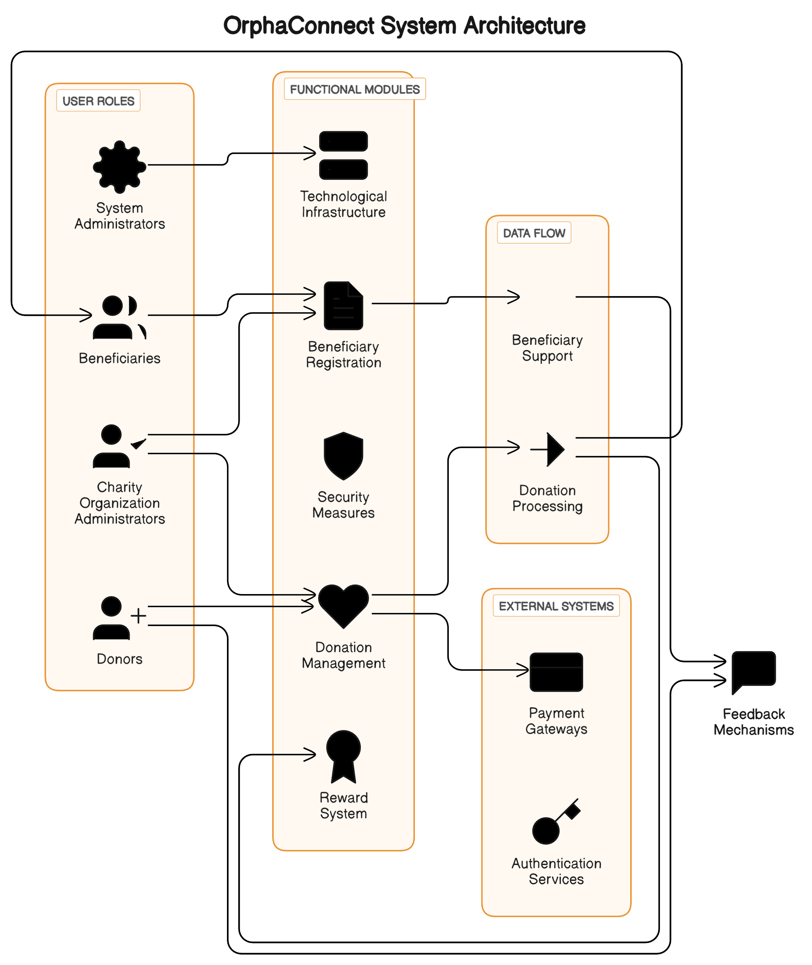

Fig 1.1 System Architecture

Overall, OrphaConnect's architectural design and technological stack are meticulously crafted to support its mission of facilitating charitable giving and efficient resource management, delivering a seamless and empowering experience for users while leveraging the capabilities of MongoDB Atlas, Twilio, and Google Maps API to enhance functionality and user engagement.

Overall, OrphaConnect's architectural design and technological stack are designed to support its mission of facilitating charitable giving and efficient resource management, delivering a seamless and empowering experience for users.

1. **IMPLEMENTATION**

The implementation of OrphaConnect marks a significant leap forward in leveraging technology to address critical needs within the orphan care sector, offering a sophisticated web-based platform designed to connect orphanages with potential donors and volunteers. Rooted in a meticulous approach to addressing the multifaceted challenges faced by orphan care organizations, OrphaConnect serves as a centralized hub where orphanages can articulate their needs, ranging from financial assistance to specific item donations, while volunteers can offer their time and skills to support these institutions in their noble endeavors.

At the heart of OrphaConnect's technological infrastructure lies the MERN stack - MongoDB, Express.js, React.js, and Node.js - a powerful ensemble of technologies renowned for their agility, scalability, and versatility in crafting dynamic web applications. MongoDB, as the backend database, provides a flexible and scalable solution for managing diverse data types, ensuring efficient data storage and retrieval. Express.js, known for its minimalist and robust framework, accelerates the development of server-side applications, facilitating seamless communication between the client and server. React.js, meanwhile, empowers the creation of interactive and responsive user interfaces, enhancing the overall user experience. Node.js serves as the runtime environment, enabling server-side scripting and facilitating real-time communication, thereby underpinning the platform's responsiveness and efficiency.

The adoption of a prototyping development methodology underscores OrphaConnect's commitment to iterative refinement and responsiveness to user feedback. This iterative approach allows for the gradual enhancement of features and functionalities, ensuring that the platform remains finely attuned to the evolving needs of orphanages, donors, and volunteers. Moreover, the agile framework provides the flexibility necessary to accommodate changes and expansions throughout the development lifecycle, ensuring that OrphaConnect evolves in tandem with the needs of its users.

OrphaConnect's seamless integration of external services, such as Twilio for OTP message delivery and the Google Maps API for location-based services, further enriches the user experience and enhances platform functionality. These integrations streamline communication and interaction between users, optimize administrative processes, and provide valuable insights into user engagement and behavior, thereby enhancing the overall effectiveness and utility of the platform.

In addition to its focus on functionality and user experience, OrphaConnect places paramount importance on security measures to safeguard user data and uphold user privacy. Rigorous encryption protocols, coupled with stringent access control mechanisms and regular security audits, are meticulously implemented to mitigate potential risks and vulnerabilities, fostering trust and confidence among users.

In summary, OrphaConnect represents a groundbreaking initiative that harnesses the power of technology to drive positive social change within the orphan care sector. By leveraging cutting-edge web development technologies and methodologies, OrphaConnect aims to revolutionize the operations of orphan care organizations, fostering greater collaboration, transparency, and impact within the global orphan care community.

1. **FUTURE WORKS**

In plotting the future trajectory of OrphaConnect, a comprehensive strategy unfolds, outlining avenues for advancement poised to elevate the platform's efficacy and impact within the rare disease and disability community. Chief among these strategic objectives is the seamless transition from a web-centric interface to a robust mobile application, ensuring ubiquitous access to OrphaConnect's indispensable resources and support networks. This evolution promises to enhance user convenience and accessibility, facilitating engagement and interaction on-the-go.

In tandem with this technological evolution, forging strategic partnerships with corporate entities emerges as a pivotal initiative. Such alliances aim to enrich user experiences through tailored incentives and exclusive offers, amplifying the platform's appeal and fostering sustained engagement. By leveraging the resources and reach of corporate partners, OrphaConnect can broaden its scope and deepen its impact within the community.

Moreover, a steadfast commitment to inclusivity underpins OrphaConnect's future endeavors, driving the integration of specialized accessibility features and an expanded product line tailored to the unique needs of diverse user demographics. By prioritizing accessibility, the platform aims to ensure that all individuals, regardless of ability, can fully utilize and benefit from its services.

Simultaneously, the establishment of a dynamic volunteer ecosystem emerges as a cornerstone initiative. By cultivating a robust network of volunteers, OrphaConnect seeks to foster community engagement, amplify its outreach efforts, and facilitate meaningful connections between users and supporters. Through volunteerism, the platform endeavors to nurture a sense of belonging and mutual support within the community.

Finally, embracing cutting-edge AI-driven analytics holds promise in unlocking invaluable insights into user behavior and preferences. By harnessing the power of data analytics, OrphaConnect aims to gain a deeper understanding of user needs, preferences, and trends. This data-driven approach empowers the platform to optimize service delivery, personalize user experiences, and anticipate evolving community needs effectively.

In pursuing these concerted future works, OrphaConnect endeavors to chart a transformative path forward, solidifying its position as a beacon of support and empowerment for individuals navigating the challenges of rare diseases and disabilities. Through innovation, collaboration, and a steadfast commitment to its mission, OrphaConnect stands poised to make enduring contributions to the well-being and resilience of the community it serves.

1. **REFERENCES**
2. N. Alblihed, M. Almutairi, R. Almahmoud, S. Aladhadh and A. Alabdulatif, "Developing Food Charity Operations Management System," 2022 2nd International Conference on Computing and Information Technology (ICCIT), Tabuk, Saudi Arabia, 2022.
3. D.I.De Silva, W.A.C Pabasara, S.A.N Wimalasooriya, H.M.C.D Samaraweera, W.S.D Thenabandu, B.A.D.K.M Balachandra, M.G.R Pasan, “Donation Management System,” 2023 2nd International Conference on Computing and Information Technology (ICCIT), 2023. <https://www.researchgate.net/publication/370403656_Donation_Management_System>
4. C. Varghese, D. Pathak and A. S. Varde, "SeVa: A Food Donation App for Smart Living," 2021 IEEE 11th Annual Computing and Communication Workshop and Conference (CCWC), NV, USA, 2021.
5. Naomi, J., Jeniel, R., Eswaran, K., & Kumaar, N. (2021). Intelligent Transaction System for Fraud Detection using Deep Learning Networks. Journal of Physics: Conference Series, 1916.
6. R. Shinta Oktaviana, D. A. Febriani, I. Yoshana and L. R. Payanta, "FoodX, a System to Reduce Food Waste," 2020 3rd International Conference on Computer and Informatics Engineering (IC2IE), Yogyakarta, Indonesia, 2020.
7. H. S. Elganzoury, A. A. Abdelhafez and A. A. Hegazy, "A new secure one-time password algorithm for mobile applications," 2018 35th National Radio Science Conference (NRSC), Cairo, 2018.
8. R. Kurup and G. P. Sajeev, "Task recommendation in reward-based crowdsourcing systems," 2017 International Conference on Advances in Computing, Communications and Informatics (ICACCI), Udupi, India, 2017.
9. T. Alloui, I. Boussebough and A. Chaoui, "Learning and modelling user interests using user feedback : A novel approach," 2015 Fifth International Conference on Digital Information Processing and Communications (ICDIPC), Sierre, Switzerland, 2015.
10. S. T. Kadam and S. Bajpai, "Development of Web Annotation Technique for Search Result Records Using Web Database," 2015 International Conference on Computing Communication Control and Automation, Pune, India, 2015.
11. H. Xie, J. C. S. Lui, J. W. Jiang and W. Chen, "Incentive mechanism and protocol design for crowdsourcing systems," 2014 52nd Annual Allerton Conference on Communication, Control, and Computing (Allerton), Monticello, IL, USA, 2014.
12. Y. Wu, Z. Liang and L. Liu, "Design and implementation of tourism information system based on Google Maps API," 2013 21st International Conference on Geoinformatics, Kaifeng, China, 2013.